**HT12E**

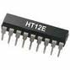

HT12E is an encoder integrated circuit of 212 series of encoders. They are paired with 212 series of decoders for use in remote control system applications. It is mainly used in interfacing RF and infrared circuits. The chosen pair of encoder/decoder should have same number of addresses and data format.

Simply put, HT12E converts the parallel inputs into serial output. It encodes the 12 bit parallel data into serial for transmission through an RF transmitter. These 12 bits are divided into 8 address bits and 4 data bits.

HT12E has a transmission enable pin which is active low. When a trigger signal is received on TE pin, the programmed addresses/data are transmitted together with the header bits via an RF or an infrared transmission medium. HT12E begins a 4-word transmission cycle upon receipt of a transmission enable. This cycle is repeated as long as TE is kept low. As soon as TE returns to high, the encoder output completes its final cycle and then stops.

**Pin Diagram:**

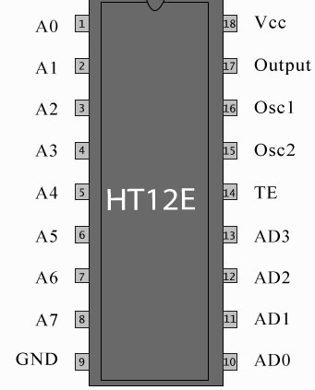

**Pin Description:**

|  |  |  |
| --- | --- | --- |
| **Pin No** | **Function** | **Name** |
| 1 | 8 bit Address pins for input | A0 |
| 2 | A1 |
| 3 | A2 |
| 4 | A3 |
| 5 | A4 |
| 6 | A5 |
| 7 | A6 |
| 8 | A7 |
| 9 | Ground (0V) | Ground |
| 10 | 4 bit Data/Address pins for input | AD0 |
| 11 | AD1 |
| 12 | AD2 |
| 13 | AD3 |
| 14 | Transmission enable; active low | TE |
| 15 | Oscillator input | Osc2 |
| 16 | Oscillator output | Osc1 |
| 17 | Serial data output | Output |
| 18 | Supply voltage; 5V (2.4V-12V) | Vcc |